Zaki Kidane

ASTR 1000

My Personal Horizon Diagram.

Use complete sentences to describe how you determined the location north.

🡪 I used Google Maps to determine the location North. It has a compass feature and one which shows the phone’s alignment. I made my phone horizontal and aligned the direction I was facing with the ‘North’ pointer on the compass sign.

Picture facing north from your perspective.



Picture facing east from your perspective.

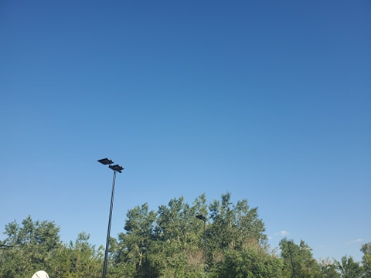

Picture facing south from your perspective.



Picture facing west from your perspective.

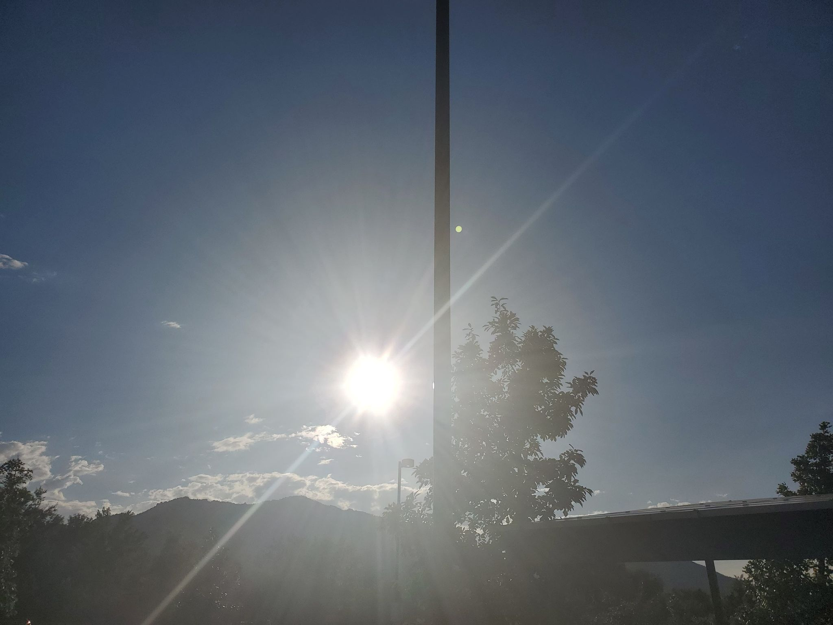

Your personal horizon diagram sketch:

